**OT LAB ASSIGNMENT 4**

**Question 1**

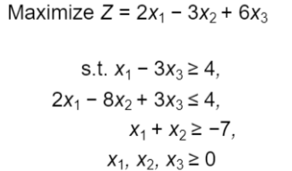

**Code:**

%% Convert the problem into standard form

% Max z = 2x1-3x2+6x3

% s.t.x1-3x3>=4

% 2x1-8x2+3x3<=4

% x1+x2>=-7

% x1,x2,x3>=0

clc

clear all

close all

format short

% phase 1 input parameteres

c=[2 -3 6]; %cost of objectivve function

A = [1 0 -3;2 -8 3;1 1 0];

B=[4;4;-7]; %RHS of the constraint

for i = 1:size(B,1)

if B(i,:)<0

A(i,:)=-A(i,:);

B(i)=-B(i);

end

end

% Phase 2 Identify <= or >= types constraint

Ineqsign=[-1 1 1]; %-1 for greater than sign 1 for less than sign

% Introduce slack and surplus variable

s = eye(size(A,1));

index = find(Ineqsign<0);

s(index,:) = -s(index,:);

% Phase 4 To write standard form

objfun= array2table(c);

objfun.Properties.VariableNames(1:size(c,2))={'x1','x2','x3'};

Mat=[A s B];

const=array2table(Mat);

const.Properties.VariableNames(1:size(Mat,2))={'x1','x2','x3','s1','s2','s3','sol'};

disp("The cost function:")

objfun

disp("The function in Standard Form:")

const

**Output:**

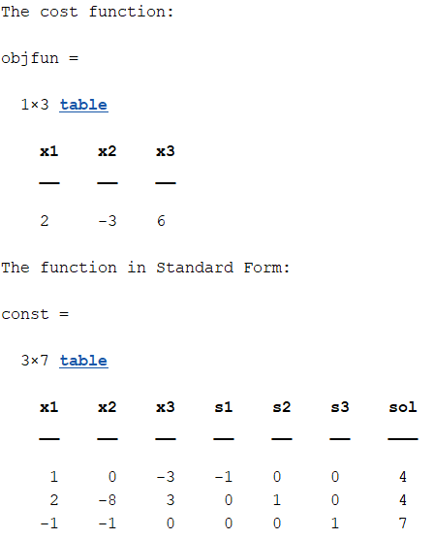

**Question 2**

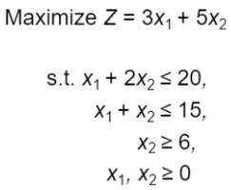

**Code:**

%% Convert the problem into standard form

% Max z = 3x1+5x2

%s.t. x1+2x2<=20

% x1+x2<=15

% x2>=6

% x1,x2,x3>=0

clc

clear all

close all

format short

% phase 1 input parameteres

c=[3 5]; %cost of objectivve function

A = [1 2 ;1 1;0 1];

B=[20;15;6]; %RHS of the constraint

for i = 1:size(B,1)

if B(i,:)<0

A(i,:)=-A(i,:);

B(i)=-B(i);

end

end

% Phase 2 Identify <= or >= types constraint

Ineqsign=[1 1 -1]; %-1 for greater than sign 1 for less than sign

% Introduce slack and surplus variable

s = eye(size(A,1));

index = find(Ineqsign<0);

s(index,:) = -s(index,:);

% Phase 4 To write standard form

objfun= array2table(c);

objfun.Properties.VariableNames(1:size(c,2))={'x1','x2'};

Mat=[A s B];

const=array2table(Mat);

const.Properties.VariableNames(1:size(Mat,2))={'x1','x2','s1','s2','s3','sol'};

disp("The cost function:")

objfun

disp("The function in Standard Form:")

const

**Output:**

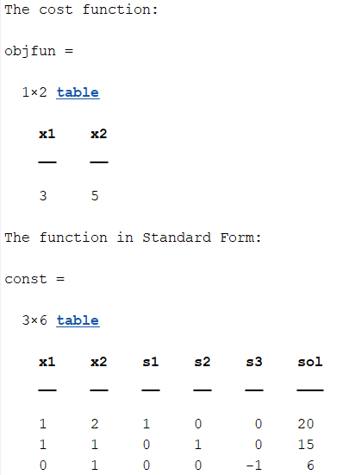

**Question 3**

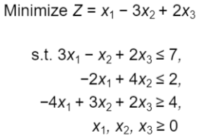

**Code:**

%% Convert the problem into standard form

% Min z = x1-3x2+2x3

%s.t. 3x1-x2+2x3<=7

% -2x1+4x2<=2

% -4x1+3x2+2x3>=4

% x1,x2,x3>=0

clc

clear all

close all

format short

% phase 1 input parameteres

c=[1,-3,2]; %cost of objectivve function

A = [3,-1,2;-2,4,0;-4,3,2];

B=[7;2;4]; %RHS of the constraint

for i = 1:size(B,1)

if B(i,:)<0

A(i,:)=-A(i,:);

B(i)=-B(i);

end

end

% Phase 2 Identify <= or >= types constraint

Ineqsign=[1,1,-1]; %-1 for greater than sign 1 for lss than sign

% Introduce slack and surplus variable

s = eye(size(A,1));

index = find(Ineqsign<0);

s(index,:) = -s(index,:);

% Phase 4 To write standard form

objfun= array2table(c);

objfun.Properties.VariableNames(1:size(c,2))={'x1','x2','x3'};

Mat=[A s B];

const=array2table(Mat);

const.Properties.VariableNames(1:size(Mat,2))={'x1','x2','x3','s1','s2','s3','sol'};

disp("The cost function:")

objfun

disp("The function in Standard Form:")

const

**Output:**

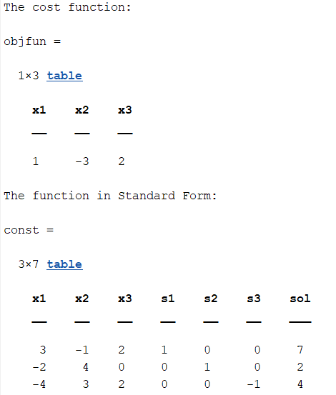

**Question 4**

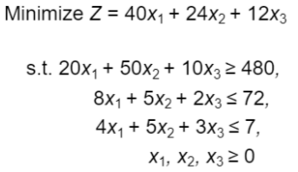

**Code:**

%% Convert the problem into standard form

% Min z = 40x1+24x2+12x3

%s.t. 20x1+50x2+10x3>=480

% 8x1+5x2+2x3<=72

% 4x1+5x2+3x3<=7

% x1,x2,x3>=0

clc

clear all

close all

format short

% phase 1 input parameteres

c=[40,24,12]; %cost of objectivve function

A = [20,50,10;8,5,2;4,5,3];

B=[480;72;7]; %RHS of the constraint

for i = 1:size(B,1)

if B(i,:)<0

A(i,:)=-A(i,:);

B(i)=-B(i);

end

end

% Phase 2 Identify <= or >= types constraint

Ineqsign=[-1 1 1]; %-1 for greater than sign 1 for less than sign

% Introduce slack and surplus variable

s = eye(size(A,1));

index = find(Ineqsign<0);

s(index,:) = -s(index,:);

% Phase 4 To write standard form

objfun= array2table(c);

objfun.Properties.VariableNames(1:size(c,2))={'x1','x2','x3'};

Mat=[A s B];

const=array2table(Mat);

const.Properties.VariableNames(1:size(Mat,2))={'x1','x2','x3','s1','s2','s3','sol'};

disp("The cost function:")

objfun

disp("The function in Standard Form:")

const

**Output:**

